AFTER ACTION REPORT: KINCADE FIRE IMPACT AND LESSONS LEARNED
The table on the next page is a summary of a meeting held by CERT on November 4, 2019 to define what was done and what lessons were learned during the period following the Kincade fire that began October 23, 2019.. Participants included:
- Members of the Community Emergency Response Team (CERT).
- Lynda Hopkins, 5th district County Supervisor.
- BBFPD Chief, Asst. Chief and Captain (operating as Incident Commander).
- Officers from the Sonoma County Sheriff’s Office.
- Officer from the California Highway Patrol.
- Management of the Bodega Bay Utilities District.
The aerial photograph below shows the direction of the wind and fire to the coast. Comments are welcome.
Dewey Kribs
dkribs@bbfpd.org
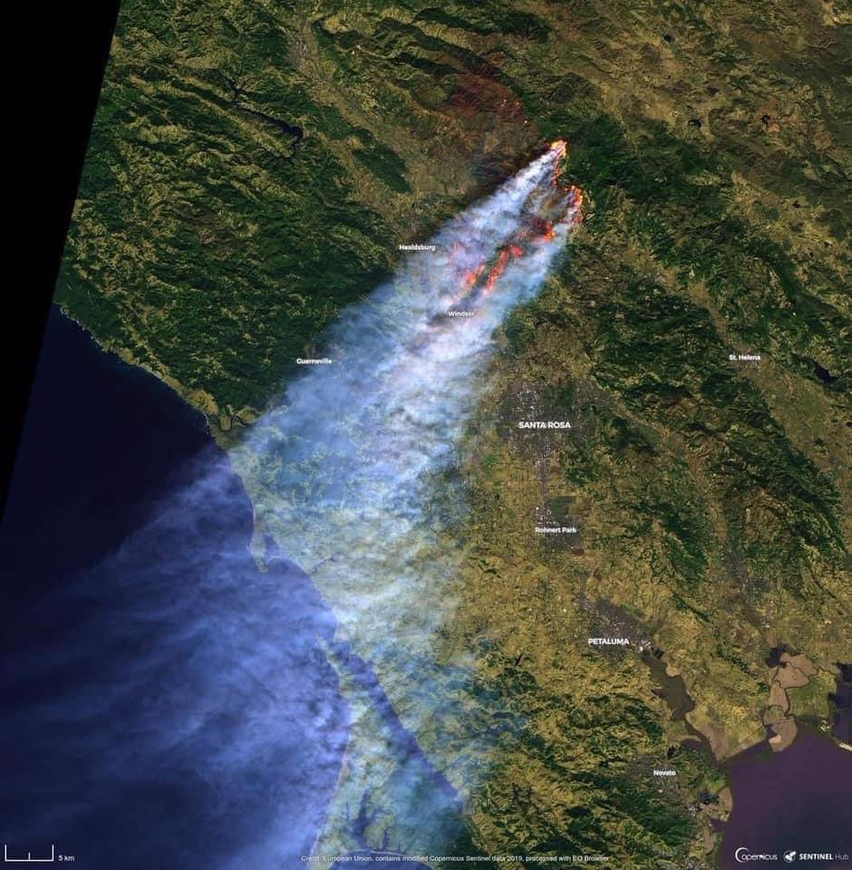

The table is based on grouping of discussions as they came up. Topic names are based on the questions people raised during the meeting. This a draft for review only. Do not publish.

Topics and Questions Raised | What Happened | Lessons Learned/ Action Items
What was the risk of fire to Bodega Bay? (and Sonoma County Coast generally?) | Data from two sources.  - CALFIRE  - BBFPD OPERATIONS  On October 26/27 (early Saturday afternoon into Sunday morning) all CALFIRE models of the fire showed the fire not stopping until it reached Jenner and the ocean. Before long it became evident that the fire was moving exactly the way models predicted. This was the basis for issuing mandatory evacuations through to the coast.  BBFPD staff actively recorded climate conditions locally during this time. For example, on October 24 the humidity level was 4%. Never seen before. Readings of the Fuel Moisture (water content of vegetation) were in the high hazardous zone. A BBFPD patrol along Coleman Road counted six Fire Starts (conditions in which, if power had been on, a fire would have started) including the falling of an 80 foot Redwood tree across power lines and the road. | The new reality.  CALFIRE, Sonoma County Sheriff, and our local BBFPD Firefighters agreed with the decisions to cut power and evacuate. The Sonoma Coast, including Bodega Bay was at risk.  The wind speed and dry vegetation made it likely that fire could spread so quickly that it could not be contained.  All concurred the risk to Bodega Bay was high.
Why did Bodega Bay have a power shutdown? | The climatic conditions made it more probable for even power distribution in good working order to be impacted. It is likely we would have had fire threats started locally without power shutoff. See the narrative about BBFPD climate recordings and patrols above. | From the fire fighters viewpoint  we would have had local fires started during this time if power had been on. In addition, the containment of the Kincade fire was initially slow and uncertain thereby threatening power distribution infrastructure and causing more fire.
Topics and Questions Raised | What Happened | Lessons Learned/ Action Items
Why should I evacuate?  Where should I go? | The following reasons to evacuate were given during the meeting:  - allowed firefighters to fight the fire instead of rescuing residents.  - Reduce the danger to 1st responders fighting the fire.  - Allowed free movement of fire apparatus and 1st responders generally.  - Got people out of harms way.  - Sufficient time was given to allow residents to warn and help others.  - Law officers can spot intruders more easily  The Sonoma County EOC worked 24/7 to update evacuation needs and routes. | Evacuations were proper and necessary.  Hi/Lo sirens were used to warn citizens who might not be monitoring warning messages and worked well.  Our district Sheriff’s Sergeant said the we had 18 patrol cars, each with two officers, to carry our such activities as evacuation warnings and indicate routes (through Russian river and coast). Officers came from outside to assist in evacuations and direct to routes.
What would have happened if Bodega Bay was not in the area of PSPS and evacuation.  What if Bodega Bay doesn’t evacuate but the rest of the County does? | CERT members raised the possibility of Bodega Bay not being required to evacuate. Based on our Tubbs fire experience we would again be overwhelmed with refugees on the beaches, campgrounds and streets. We received no compensation for the sizable and charitable efforts made by our citizens. | No solutions were offered.

Topics and Questions Raised | What Happened | Lessons Learned/ Action Items
How do I get information on power shutdowns and evacuations? Don’t power shutdowns make it harder to know what is happening? | Power shutdowns also make it harder to get information. Both land lines and cell phones are impacted.  People who had phones called into the BBFPD station for information but that was not the best source since the crews were often more concerned with other matters.  In addition, additional backup information , such as was the case for the mandatory evacuation notice , didn’t come in for another 1 ½ hours. | We need to rethink the relationship of communication to power shutoffs.  Fortunately, the orders to evacuate came through before power was shut off. Once power was shutoff it became harder to get information. In fact, many didn’t repopulate until power was restored.  Seniors may be especially at risk of information scarcity. An older population may not use some media such as facebook.
How did our Fire District and Law enforcement react? | BBFPD had a total recall of all staff including volunteers.  The community was covered at all times even though some resources (such as our water tender) were sent out to fight the Kincade fire. This is due to our significant volunteer force augmenting paid staff and the recent upgrades in manning provided through the County.  -----------------------------------  BBFPD station had room for law enforcement to coordinate, rest, and gather information. There were sometimes more black and whites than red vehicles in the parking lot.  Many Law officers came from outside the district to assist in evacuations, remove intruders in evacuation zones, and other matters. At one time there were 18 patrol cars of 2 officers each patrolling Russian River District (including Bodega Bay). | The fire station itself experienced some difficulties particularly when the Internet went down. BBFPD is “hardening” resources to prevent this in the future. Hot spots are being set up, fiber optics are being studied, and more/better backups are planned.  The BBFPD staff thanked the numerous community members who brought in food and well wishes during the efforts.  As pointed out by the Sheriff Sergeant, people who shelter in place, rather than evacuate, have no guarantee that officers can help them.  While no one was arrested for not evacuating, every effort, including door to door sweeps was made to inform residents, renters, and any others of the orders.  Unfortunately, we have limited roads for evacuation. It will only take one broken 40 foot trailer to hinder an orderly evacuation.
How did our utilities District fare? | The Bodega Bay Utilities District continued to operate off backup power, repositioning of generators and pumps as needed. There were about 3 days of water supply available at the time of the shutdown.  Other water districts warned users to economize in their use because the water supply will be limited in a power shutdown. | Normal usage of water in BB is about 300 gallons per day. During the time of mandatory evacuation it fell to about 50,000 gallons per day.  The Sereno Del Mar/Carmet water supply, for example, had a 300,000-gallon storage tank filled with filtered, treated water. This is the ONLY supply of treated water the system will have during the power shutoff.

Topics and Questions Raised | What Happened | Lessons Learned/ Action Items
How can I prepare for the next time? | Items mentioned included:  - The Go Bag(s) including for the house, children, pets, medications, etc.  - One Gallon of water per person per day  - Medications and health information  - Readily accessible clothes and shoes (perhaps placed under the bed)  - Radio with battery and charger  - Full tank of gas  - Creature comforts  - Ham radios (if Ham)  - Remember to check your neighbors | Most of us found that we missed something this time and need to restock and repack or do a better checklist.
How did our CERT Amateur Radio Operators react. | As per the BBFPD PSPS plan the CERT Hams were notified by email of a pending need for the emergency Net implementation at least 36 to 38 hours prior to implementation. Subsequent emails requested specific volunteer names and times to fill out Net operation from the beginning of the power shutdown to its expected end as stated by PG&E: 8:00 PM Saturday through 11:00 AM Monday (round the clock). | Basing the Ham Emergency Net schedule on the power shutdowns was wrong. The evacuation warning came in a little after 1:00 PM Saturday and the Net was immediately opened to warn residents through the Net.  Then about 6:30 PM the mandatory evacuation order came through. The station operator broadcast the order and shutdown the station. All Hams were to evacuate as well.  This resulted in a review of not only Wildfire Ham procedures but other major disasters as well. All disasters are not the same. Two new guidelines; one for the Net operation and one for field operations were written and have been distributed, recognizing the differences in type of disaster.

